**·系统app代码:**

* 销售管理系统_APP.PRG

* This file is a generated, framework-enabling component

* created by APPBUILDER

* (c) Microsoft Corporation

* Framework-generated application startup program

* for C:\USERS\ADMINISTRATOR\DESKTOP\销售管理信息系统\销售管理系统 Project

#INCLUDE [..\xsglxt_APP.H]

IF TYPE([APP_GLOBAL.Class]) = "C" AND ;

UPPER(APP_GLOBAL.Class) == UPPER(APP_CLASSNAME)

MESSAGEBOX(APP_ALREADY_RUNNING_LOC,48, ;

APP_GLOBAL.cCaption )

IF VARTYPE(APP_GLOBAL.oFrame) = "O"

APP_GLOBAL.oFrame.Show()

ENDIF

RETURN

ENDIF

RELEASE APP_GLOBAL

PUBLIC APP_GLOBAL

LOCAL lcLastSetTalk, llAppRan, lnSeconds, loSplash

LOCAL ARRAY laCheck[1]

lcLastSetTalk=SET("TALK")

loSplash = .NULL.

SET TALK OFF

#IFDEF APP_SPLASHCLASS

IF NOT EMPTY(APP_SPLASHCLASS)

loSplash = NEWOBJECT(APP_SPLASHCLASS, APP_SPLASHCLASSLIB)

IF VARTYPE(loSplash) = "O"

lnSeconds = SECONDS()

loSplash.Show()

ENDIF

ENDIF

#ENDIF

APP_GLOBAL = NEWOBJECT(APP_CLASSNAME, APP_CLASSLIB)

IF VARTYPE(APP_GLOBAL) = "O" ;

AND ACLASS(laCheck,APP_GLOBAL) > 0 AND ;

ASCAN(laCheck,UPPER(APP_SUPERCLASS)) > 0

APP_GLOBAL.cReference =[APP_GLOBAL]

APP_GLOBAL.cFormMediatorName = APP_MEDIATOR_NAME

#IFDEF APP_CD

APP_CD

#ENDIF

#IFDEF APP_PATH

APP_PATH

#ENDIF

#IFDEF APP_INITIALIZE

APP_INITIALIZE

#ENDIF

IF VARTYPE(loSplash) = "O"

IF SECONDS() < lnSeconds + APP_SPLASHDELAY

=INKEY(APP_SPLASHDELAY-(SECONDS()-lnSeconds),"MH")

ENDIF

loSplash.Release()

loSplash = .NULL.

ENDIF

RELEASE laCheck, loSplash, lnSeconds

IF NOT APP_GLOBAL.Show()

IF TYPE([APP_GLOBAL.Name]) = "C"

MESSAGEBOX(APP_CANNOT_RUN_LOC,16, ;

APP_GLOBAL.cCaption )

APP_GLOBAL.Release()

ELSE

MESSAGEBOX(APP_CANNOT_RUN_LOC,16)

ENDIF

ELSE

llAppRan = .T.

ENDIF

IF TYPE([APP_GLOBAL.lReadEvents]) = "L"

IF APP_GLOBAL.lReadEvents

* the Release() method was not used

* but we've somehow gotten out of READ EVENTS...

APP_GLOBAL.Release()

ENDIF

ELSE

RELEASE APP_GLOBAL

ENDIF

ELSE

MESSAGEBOX(APP_WRONG_SUPERCLASS_LOC,16)

RELEASE APP_GLOBAL

ENDIF

IF lcLastSetTalk=="ON"

SET TALK ON

ELSE

SET TALK OFF

ENDIF

IF TYPE([APP_GLOBAL]) = "O"

* non-read events app

RETURN APP_GLOBAL

ELSE

RETURN llAppRan

ENDIF

**系统启动代码（setup）:运行后直接跳转到欢迎窗口**

set default to d:\xsglxt

set century on

clear windows

clear all

Open database data\销售管理系统数据库 exclusive

do form forms\start.scx

*read events

进入系统按钮实现：

thisform.hide

thisform.release

do form forms\main

*clear events

系统启动实现：

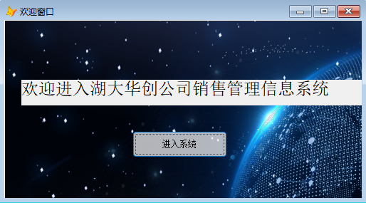

**主界面相关代码：**

释放对象时发生（destroy）

RELEASE MENU mainmenu EXTENDED

创建一个对象时发生（Init）

DO menus\MAINMENU.MPR WITH THIS

*read events

*this.mytoolbar.imagelist=this.imagelist1

*=this.mytoolbar.buttons.add(,'xsgl','',,1)

*=this.mytoolbar.buttons.add(,'bar1','',3,1)

*=this.mytoolbar.buttons.add(,'rkgl','',,2)

*=this.mytoolbar.buttons.add(,'bar2','',3,1)

系统主界面实现

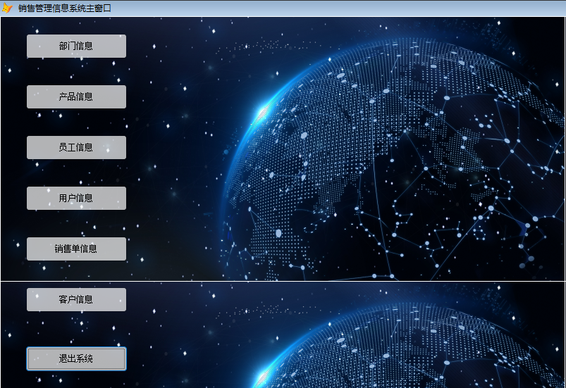

系统功能实现

部门信息查询代码

do form d:\xsglxt\forms\department

部门信息查询实现

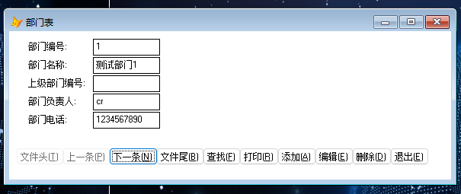

产品信息查询代码

do form d:\xsglxt\forms\product

产品信息查询实现：

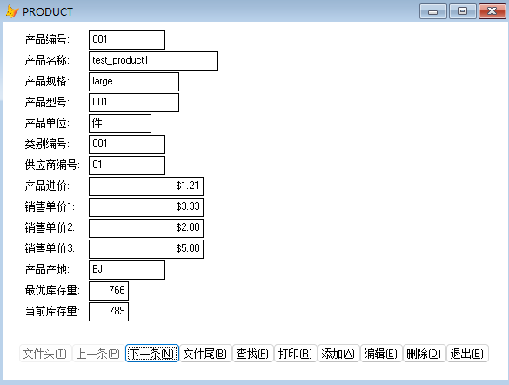

员工信息查询代码

do form d:\xsglxt\forms\employee

员工信息查询实现

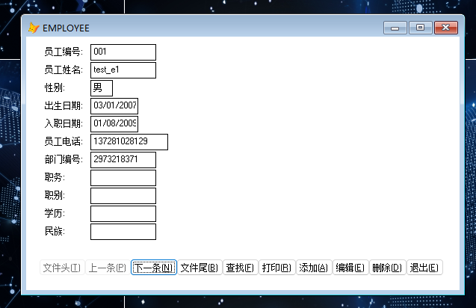

用户信息查询代码

do form d:\xsglxt\forms\user

用户信息查询实现

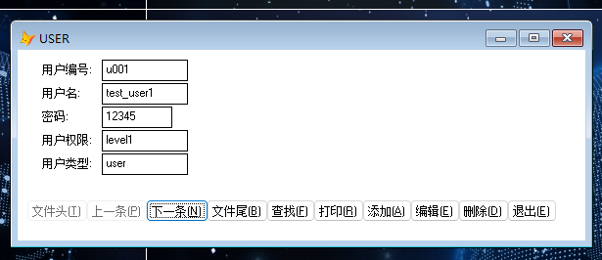

销售单信息查询代码

do form d:\xsglxt\forms\salesslip

销售单信息查询实现

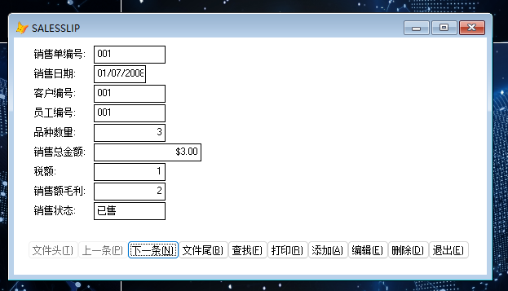

客户信息查询代码

do form d:\xsglxt\forms\customer

客户信息查询实现

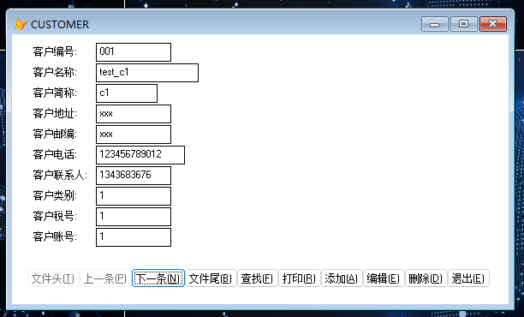退出系统代码

thisform.hide

thisform.release

clear events

系统登录界面代码

确定按钮：

*set default to d:\xsglxt

*Open database data\销售管理系统数据库.dbc

use data\user

*set index to username

locate all for username=alltrim(thisform.text1.text)

if found() then

if password1=alltrim(thisform.text2.value) then

thisform.hide

thisform.release

* DO main.mpr *do form forms\main

*read events* clear EVENTS

else

thisform.text2.setfocus

messagebox("password is error!")

endif

else

thisform.text1.setfocus

messagebox("username is error!")

endif

use

退出按钮

thisform.hide

thisform.release

main.hide

main.release

close database

*clear events

*start.release

登录界面实现

